**DAILY ONLINE ACTIVITIES SUMMARY**

|  |  |  |  |  |  |  |  |  |
| --- | --- | --- | --- | --- | --- | --- | --- | --- |
| **Date:** | **20/06/2020** | | | | | **Name:** | **Spoorthy Balaji** | |
| **Sem & Sec** | **6th & B** | | | | | **USN:** | **4al17cs098** | |
| **Online Test Summary** | | | | | | | | |
| **Subject** | |  | | | | | | |
| **Max. Marks** | |  | | **Score** | | |  | |
| **Pre-placement Training Summary** | | | | | | | | |
| **Course** | **Programming in C++** | | | | | | | |
| **Certificate Provider** | | | **Anikitha Shetty**  **Pradeep Nayak** | | **Duration** | | | **3hours** |
| **Coding Challenges** | | | | | | | | |
| **Problem Statement:** 3 Programs | | | | | | | | |
| **Status: Solved** | | | | | | | | |
| **Uploaded the report in Github** | | | | | **yes** | | | |
| **If yes Repository name** | | | | | **Online Coding Repository**  <https://github.com/spoorthybalaji/Daily_Status> | | | |
| **Uploaded the report in slack** | | | | | **yes** | | | |

**SNAPSHOTS**

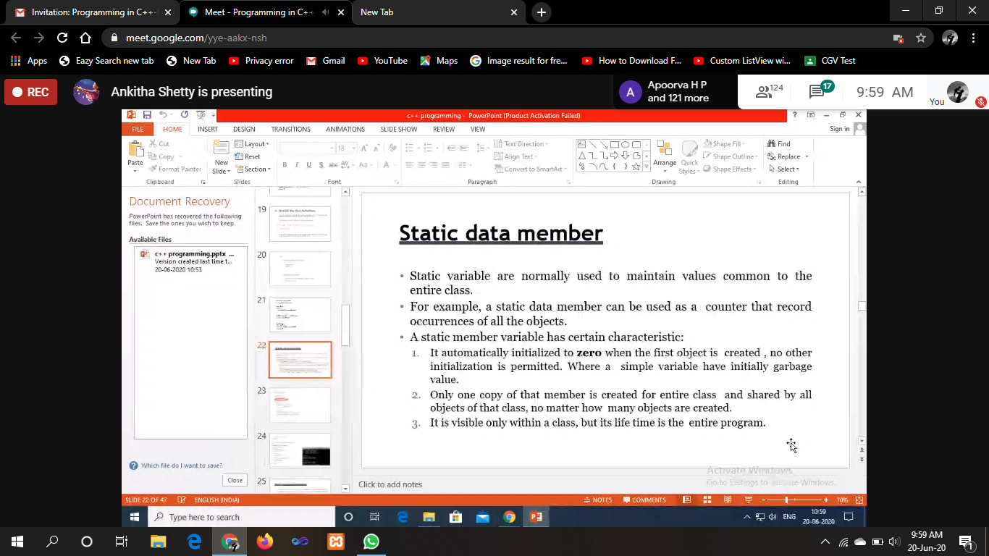

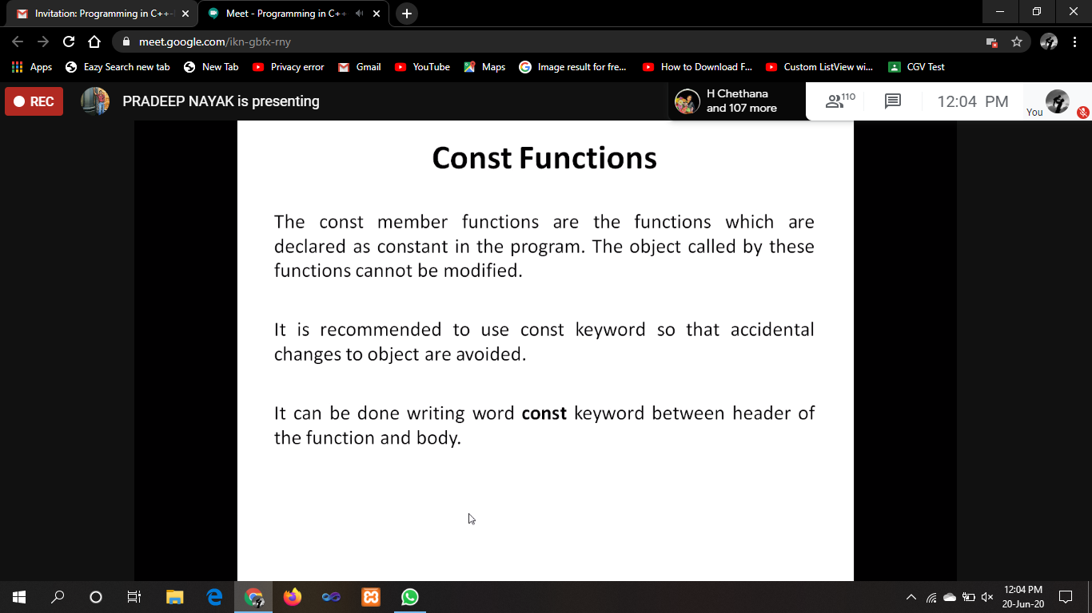

ONLINE CODING

**1. Write a Java Program to find area of Square, Rectangle and Circle using Method Overloading**

class OverloadDemo

{

void area(float x)

{

System.out.println("the area of the square is "+Math.pow(x, 2)+" sq units");

}

void area(float x, float y)

{

System.out.println("the area of the rectangle is "+x*y+" sq units");

}

void area(double x)

{

double z = 3.14 * x * x;

System.out.println("the area of the circle is "+z+" sq units");

}

}

public class Overload

{

public static void main(String args[])

{

OverloadDemo ob = new OverloadDemo();

ob.area(5);

ob.area(11,12);

ob.area(2.5);

}

}

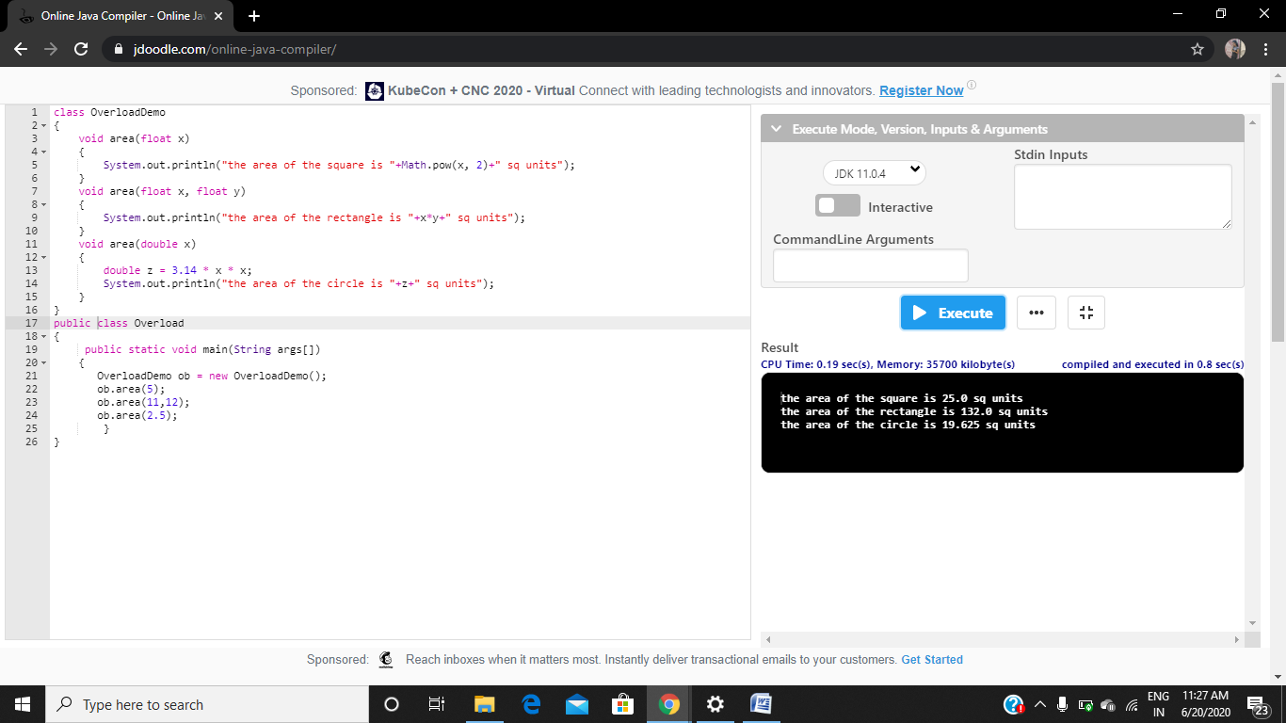

**2. Write a C Program to rotate an array by K positions.**

#include <stdio.h>

int main() {

int arr[100];

int i, N, len, j;

printf("enter n value\n");

scanf("%d",&len);

printf("enter array elements\n");

for(i=0;i<len;i++)

scanf("%d",&arr[i]);

printf("enter num rotation \n");

scanf("%d",&N);

int temp=0;

for (i = 0; i < N; i++) {

int x = arr[0];

for (j = 0; j < len; j++) {

temp=arr[j];

arr[j] = arr[j + 1];

arr[j+1]=temp;

}

arr[len - 1] = x;

}

for (i = 0; i < len; i++) {

printf("element at %d index : %d\n",i,arr[i]);

}

}

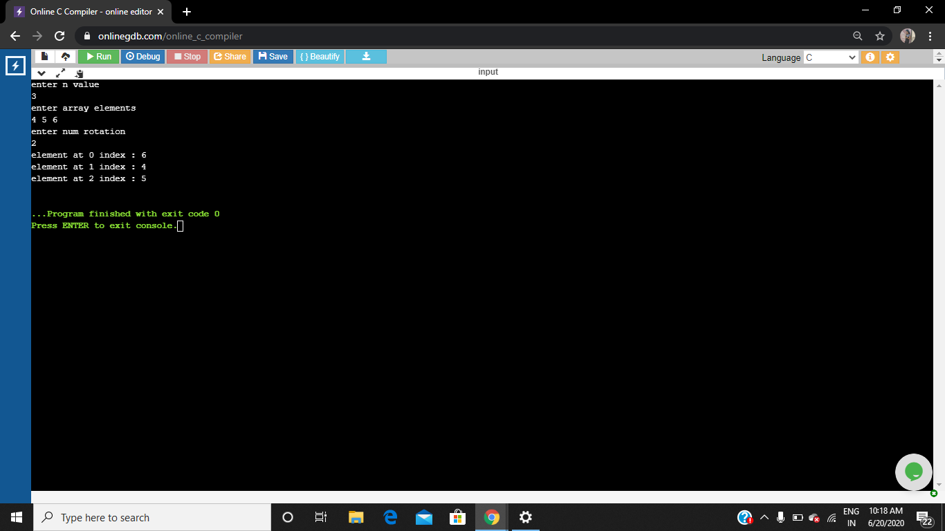

**3. Python Program that Reads a Text File and Counts the Number of Times a Certain Letter Appears in the Text File**

**fname = input("Enter file name: ")**

**l=input("Enter letter to be searched:")**

**k = 0**

**with open(fname, 'r') as f:**

**for line in f:**

**words = line.split()**

**for i in words:**

**for letter in i:**

**if(letter==l):**

**k=k+1**

**print("Occurrences of the letter:")**

**print(k)**

